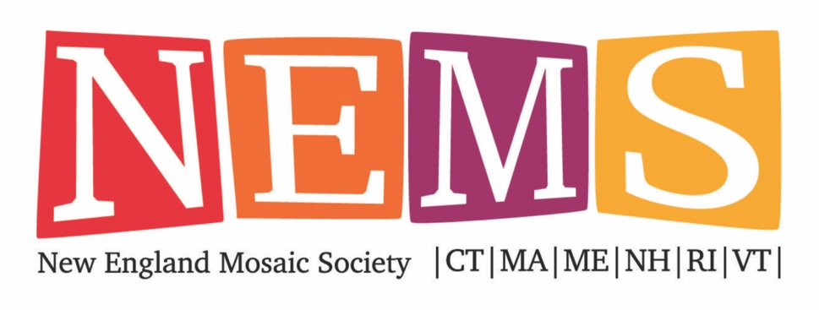
e-Application for Gear Project &
Hand Delivery or Shipping of Gear to arrive by
Deadline: January 31, 2021

Make history by mosaicking the openings of a gear for the Gear Wall of the Ruins Project. The gears will be installed in this outdoor mosaic museum in the spring of 2021. Prior to installation at the Ruins Project, the Charles River Museum of Industry and Innovation will host an online event showcasing our gears. The title of the Event is: “The Intersection of Art & Industry: Mosaicking Historic Gears for the Ruins Project.” All gears will be accepted if they meet the specifications outlined in the Call for Art.

First Name |  |  | Last Name
Email |  |  | Phone
Street Address
City |  | State |  | Zip
Name of Your Company (if applicable)

Three high resolution images are required.
- Image of the finished gear
- Image of you
- Image of you and the gear

One 30 - 60 second video is optional, but highly encouraged. Due January 31, 2021.

The Charles River Museum of Industry and Innovation has volunteered to create a video of the gear project to air during our e-event with the museum. They will take our still images and attach labels so all gears and artists will be featured in the video. If you choose to record a video, the museum staff will edit our videos and compile them into one video to showcase our work on their historic gears.

Image File Name Format:
Your Last Name_ Dimensions in inches_ Title of Piece_ Year Made.jpg
Example: Marks_12X12_Two Fish_2020.jpg

IMAGE file 1 | The Gear
Image File Name
Materials
Gear Dimensions  inches: | Length: | Width: | Height: | Yr Completed:

IMAGE file2 | A Picture of You, the Artist
Image File Name

IMAGE file 3 | A Picture of You and the Gear
Image File Name

PLEASE FILL OUT AND SIGN THE FOLLOWING WAIVER:

By submitting this application, I certify that I am a member of the New England Mosaic Society. I have read and understand the rules, and as artist and exhibitor at the 2020 NEMS Members’ Exhibition hereby waive, release, and discharge any claim I may have against New England Mosaic Society for any and all damage to, theft of, unauthorized use, or loss of my artwork. I do agree to hold New England Mosaic Society free, harmless, and indemnified from any and all such claims.

May NEMS use your artwork, with proper recognition, in promoting exhibits on their websites, and social media sites?

Yes______ No______

Artist Signature: ____________________________________Date: ___________________

DEADLINES:

Deadline for submission of the e-application is January 31, 2021. Send to the newenglandmosaicsociety@gmail.com.

Three high resolution images are required by January 31, 2021. Send to the newenglandmosaicsociety@gmail.com

- Image of the finished gear
- Image of you
- Image of you and the gear

The finished gear on mesh should arrive at the home of Amy Marks by January 31, 2021. Drop off/shipping address:

Amy Marks
111 Riverview Avenue
Waltham, MA 02453

Your short video (30-90 seconds) should be emailed by January 31, 2021 to the newenglandmosaicsociety@gmail.com.

SUBMISSION OF ARTWORK:
All images MUST be named according to the following format:

Your Last Name_Dimensions in inches_Title of Piece_Year Made.jpeg
Example: Marks_12X12_Two Fish_2020.jpeg

It is important to submit high quality photographs. We realize that many of you will have limited access to cameras or outside assistance during this time, so it is all that more difficult to create good photos. However, today’s smartphones have excellent cameras and can be used to take photographs of your art. Following are two articles that provide some guidance.

https://blog.mosaicartsupply.com/how-to-photograph-mosaic-art-and-paintings/
https://willkempartschool.com/how-to-photograph-your-paintings-with-your-iphone/

Making the Video

- Making a short video gives you the opportunity to highlight your gear mosaic and promote your work and process. You can shoot the video in your studio or wherever you create. All you need is a cell phone. The content of your video could include (but is not limited to) any of the following:
  - A shot of you in your studio or working on a mosaic
  - A closeup of the gear
  - A discussion of the materials you used to make the mosaic (tile & adhesive)
  - Your motivation for the design
  - If you pulled your own filati, tell how you made it
  - Why you wanted to be part of this project. Historic nature of the project?
- Once you introduce yourself, focus the camera on your gear and talk.

Resources for Shooting the Video on your Mobile Phone

The video below was shared with me by the Polymer Clay Symposium to help me record a class. It has good basic information about recording a video with a focus on position, light and sound. Although it mentions options for purchasing lighting and an arm or tripod to hold your cell phone camera, those items are not necessary.
First, watch this video: https://www.youtube.com/watch?v=HBVFnQBKlb0
Pointers:
- Record the video with your cell phone. Go into your camera, set your camera to video. Press video when you are ready. A square should show up in the red circle. That’s the clue you are recording.
- Find a spot with good natural light. A table in front of a window will be perfect. However you should never sit with your back to the window as all photos will come out dark. Avoid house and fluorescent lights.
- An arm cell phone holder to hold your phone will help a lot. Something like this: https://amzn.to/31CddCW
- You can also get a light to help: https://amzn.to/2MVoGbu
- Always record with your phone in the horizontal position

The following video on YouTube takes you through step-by-step of recording, editing and sending the video. The video file will be large, so, it might sending via dropbox or a program or a link from google drive.

https://www.youtube.com/watch?v=ek53TQ9U35o

Let me know if you have any questions. We’ll handle them one-on-one. You can reach me 781-635-8770 or amyloumarks@gmail.com.

The gears will not be for sale. The gears will be installed on the walls of the Ruins Project in PA.

